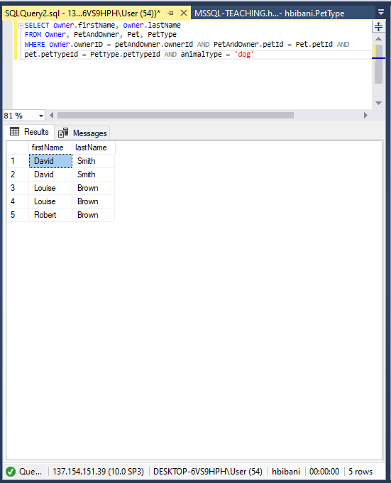

SELECT DISTINCT owner.firstName, owner.lastName
FROM Owner, PetAndOwner, Pet, PetType
WHERE owner.ownerId = PetandOwner.ownerId AND PetAndOwner.petId = Pet.petId
AND pet.petTypeId = PetType.petTypeId AND animalType = 'dog'
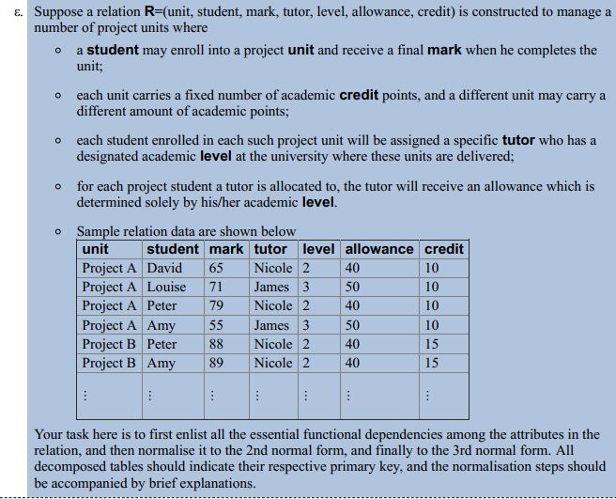

Functional Dependencies:
Unit, Student mark, Tutor, level, allowance, credit
2nd Normal Form:
Unit Credit
Unit, Student mark, tutor, level, allowance
3rd Normal Form:
Unit Credit
Unit, Student mark, Tutor
Tutor Level, Allowance
Relations:
Unit Credit
Unit, Student mark, tutor
Tutor level, allowance

